***JOB APPLICATION TRACKING SYSTEM***

1. ***INTRODUCTION***
   1. OVERVIEW

A job application tracking system is software for recruiters and employers to track candidates throughout the recruiting and hiring process. This software can come equipped with capabilities ranging from simple database functionality to a full –service suite of tools that makes it easy for businesses of any size to filter, manage, and analyze candidates.

Every organization is unique, but each one thrives on attracting, hiring, and maximizing top talent. Many businesses face major challenges at some point in the hiring or onboarding process. A JATS can offer a variety of capabilities that can help the organization find, hire, and retain the best candidate.

* 1. PURPOSE

Some of the purpose of JATS is given below,

Source and attract qualified candidates

Some organizations lack the reach to connect with top job seekers or to a cast a wide enough net in the marketplace. Others are missing critical data on the right channels to find specific candidates; other organizations may lack brand recognition and mean to develop it. A JATS can help address these critical challenges.

This helps organizations better understand candidate behavior.

Increase candidate engagement

A JATS creates greater visibility across the applicant lifecycle, so touch points don’t fall through the cracks.

Improve efficiency and lower costs

JATS creates opportunities to automate hiring cycle for the entire recruiting team, and increase opportunities for communication throughout the candidate journey.

Optimize the onboarding process

The right JATS can also assist in onboarding, ensuring that candidates who accept employment have all the information they need to start making an impact from day one, increasing overall productivity and retention.

1. ***PROBLEM DEFINITION AND DESIGN THINKING***
   1. EMPATHY MAP

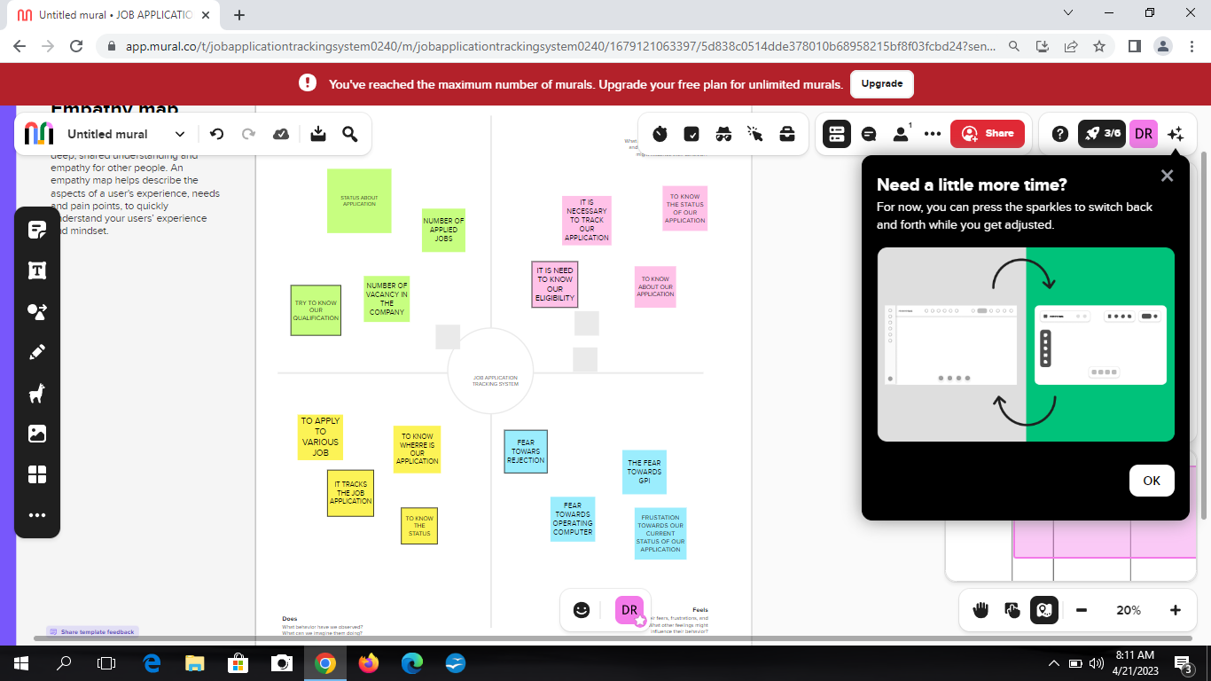

2.2IDEATION AND BRAINSTORMING MAP

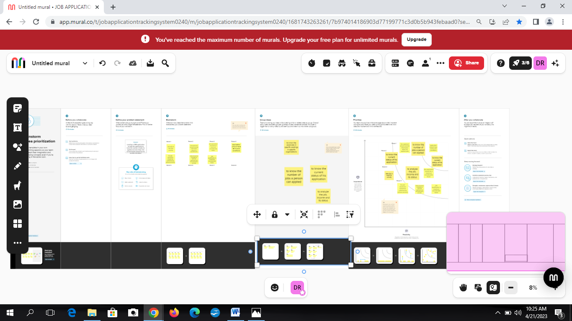

1. ***RESULT***

3.1Data model

|  |  |
| --- | --- |
| Object name | Fields in the object |
| Object 1  Custom object | |  |  | | --- | --- | | Field label | Data type | | Recruiter | Auto Number | | Jobs | Auto Number | | Candidate | Auto Number | | Job Application object | Auto Number | | Tab | Auto Number | |
| Object 2  Custom fields | |  |  | | --- | --- | | Field label | Data type | | Job title | Text | | Recruiter | Master Detail  Relationship | | Description | Text Area | | Location | Text | |

3.2Activity and screenshot

Milestone: 1

Activity: 1

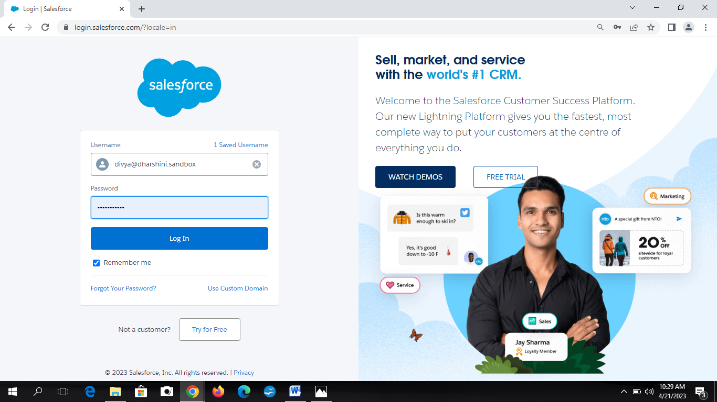

First search developer.salesforce.com then creates an account by entering mail id and password. Thus we can sign up into sales force.

Milestone: 2

Activity: 1

Open sales force web and sign in. Select the object manager and then select custom object. Mark label as “Recruiter” and data type as “Auto number” and select save.

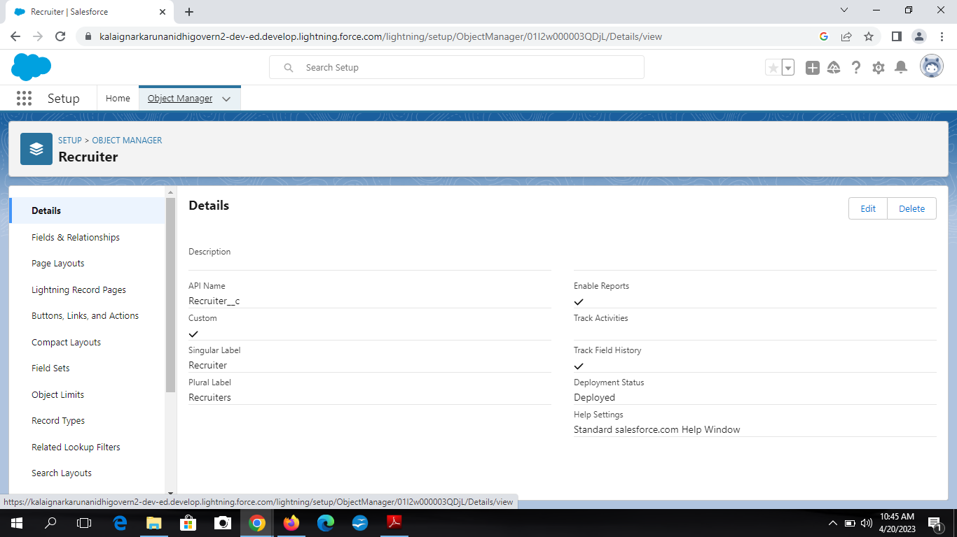

Activity:2

Now as by the previousactivity create custom object and mark label ar jobs, candiate, job application object and tab.

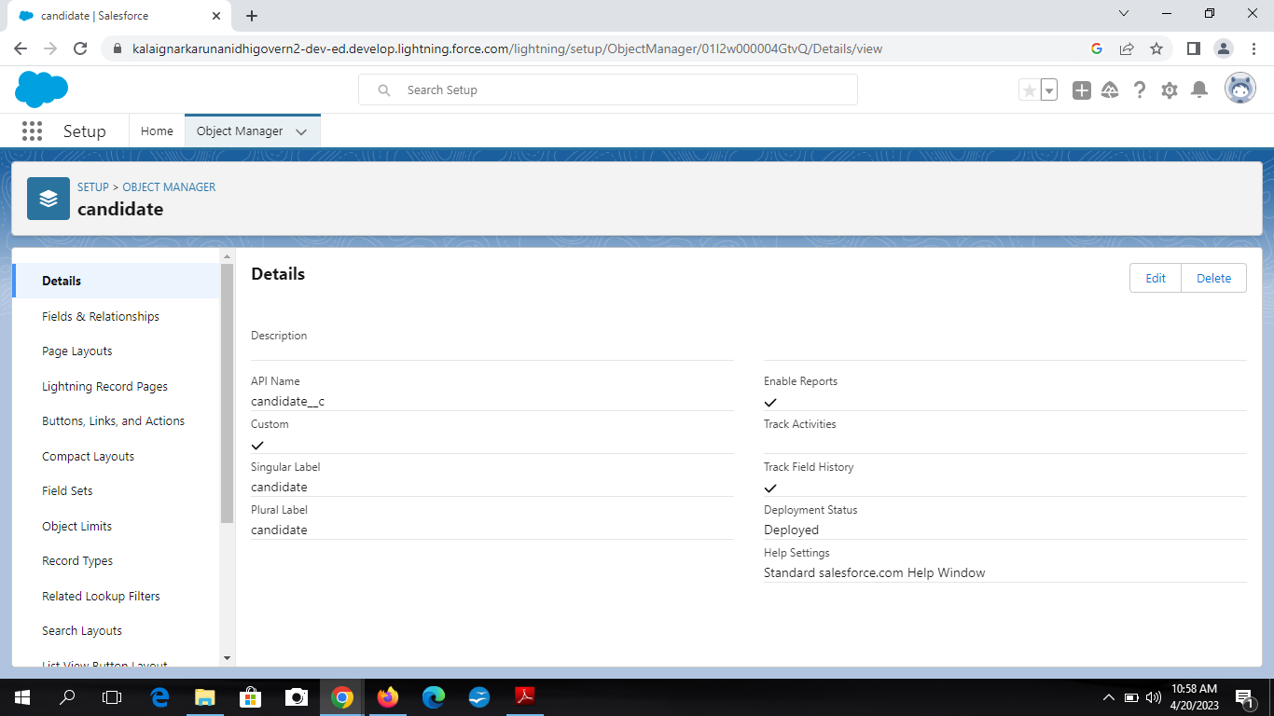

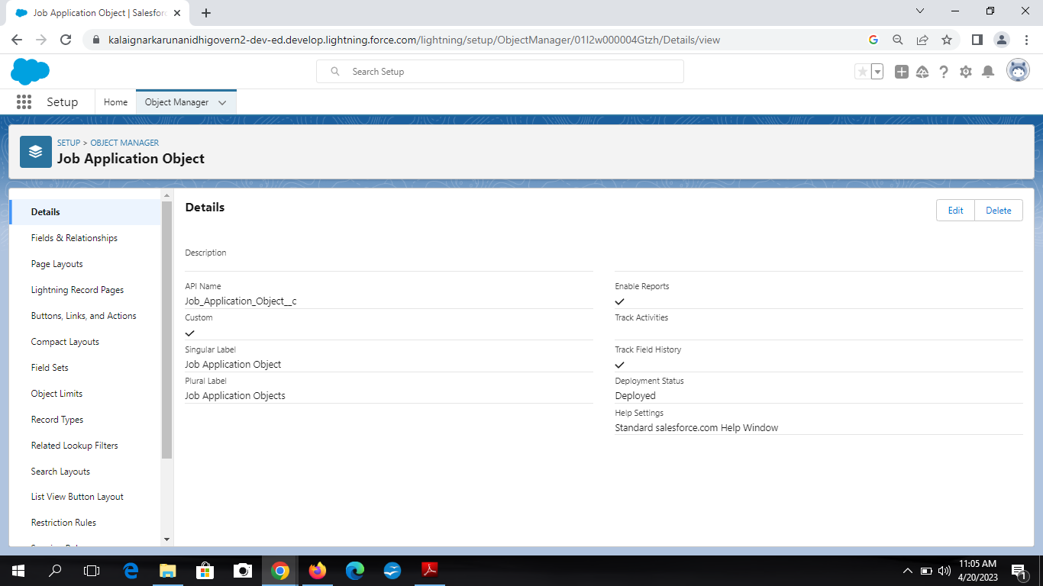

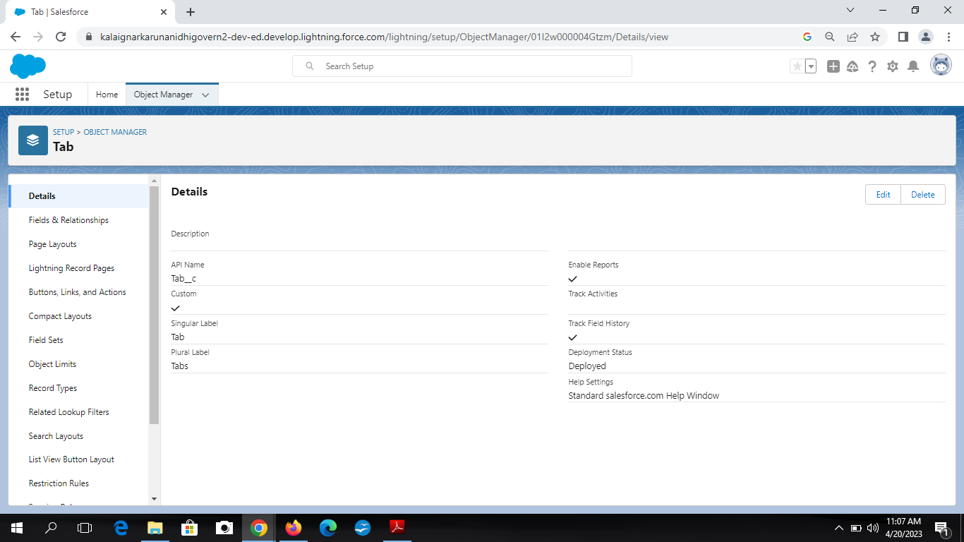

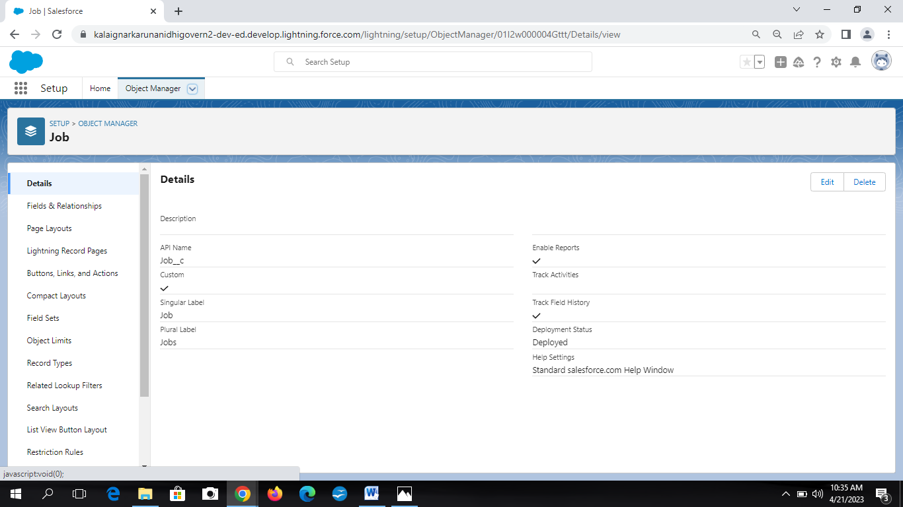

Milestone: 3

Activity: 1

To create custom fields. Click object manager tab then select Recruiter then fields & relations then select new and change data type as text and field label as Job title and save it.

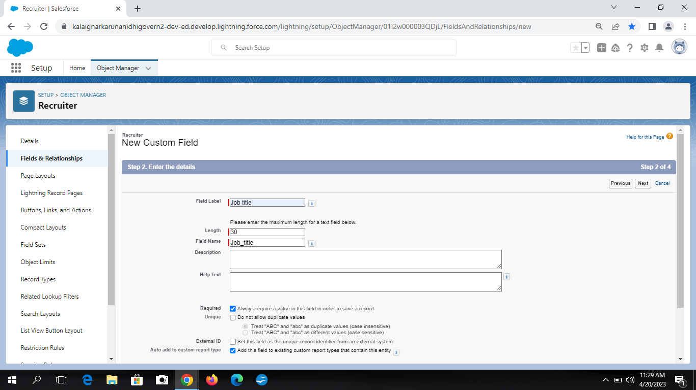

Activity: 2

Repeat the above steps then select job and select new and change data type as Master detail relationship and field label as recruiter and save it.

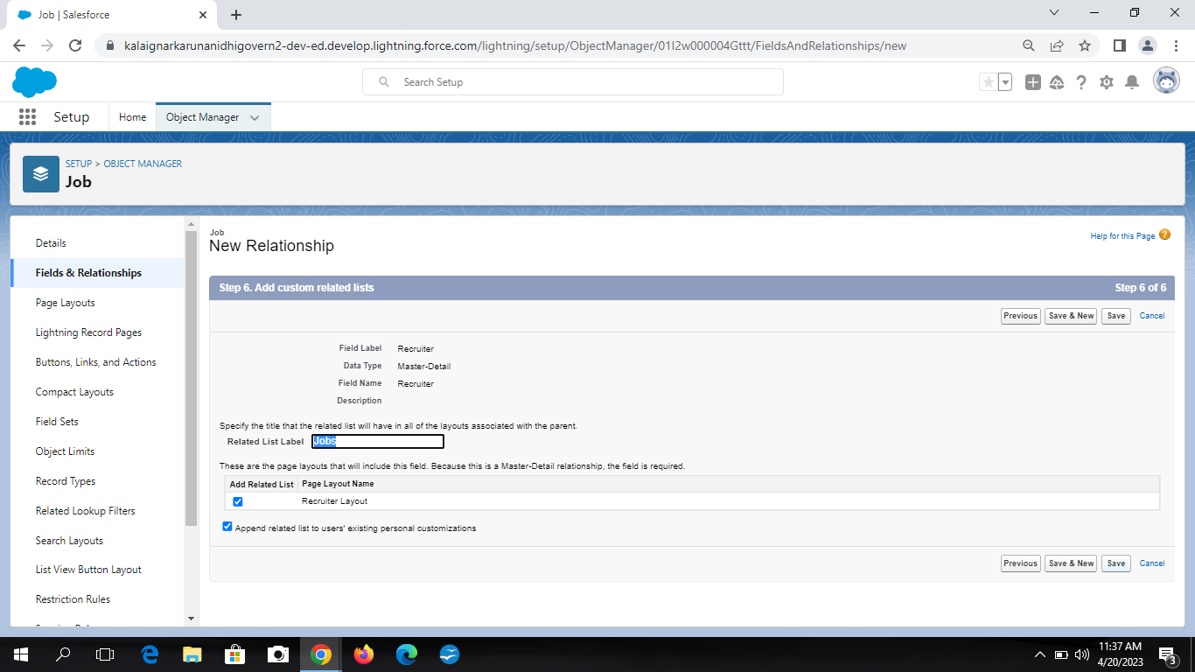

Activity: 3

Again create a new custom field in jobs and change data type as text area and field label as descriptive then save it.

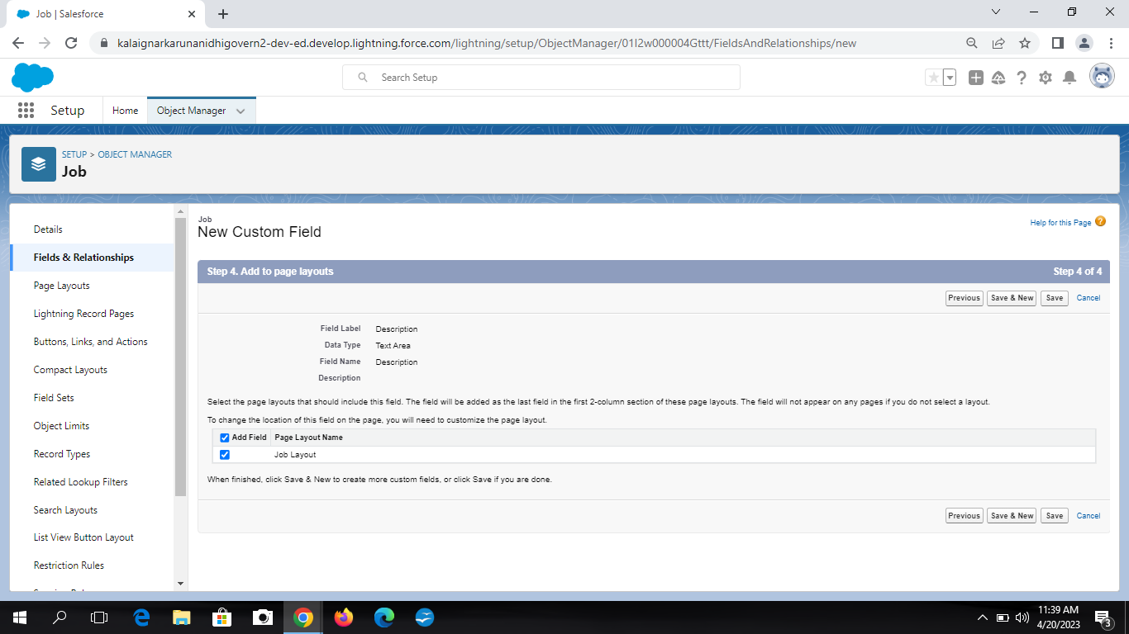

Activity: 4

Again create a new custom field in jobs by changing the data type as text ad field label as location then save it.

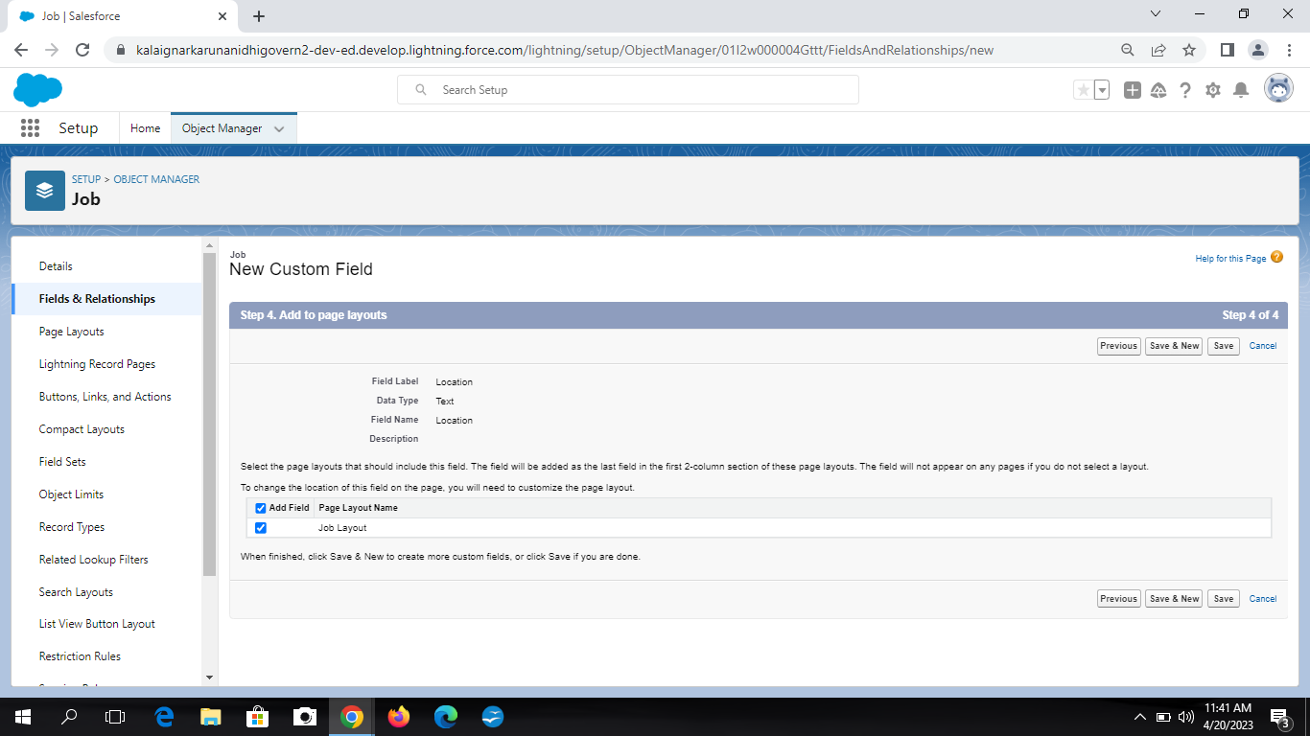

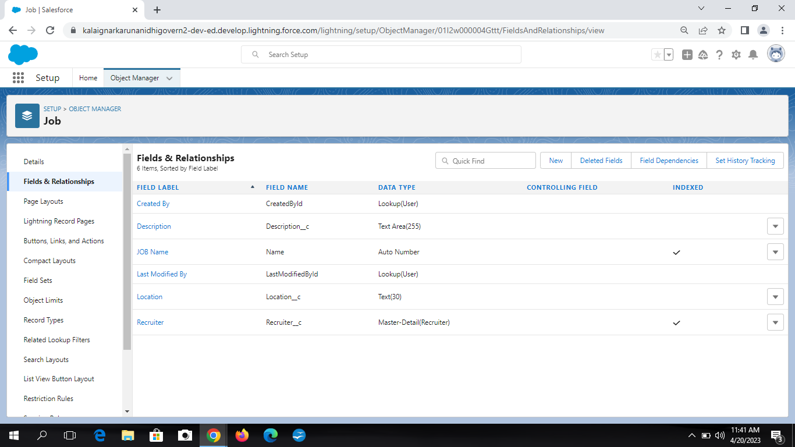Milestone: 4 Activities: 1

To create a tab click setup and search tab in quick box then select tab then section new custom object. Select the tab style for recruiter then select the profiles to visible in tab then save it.

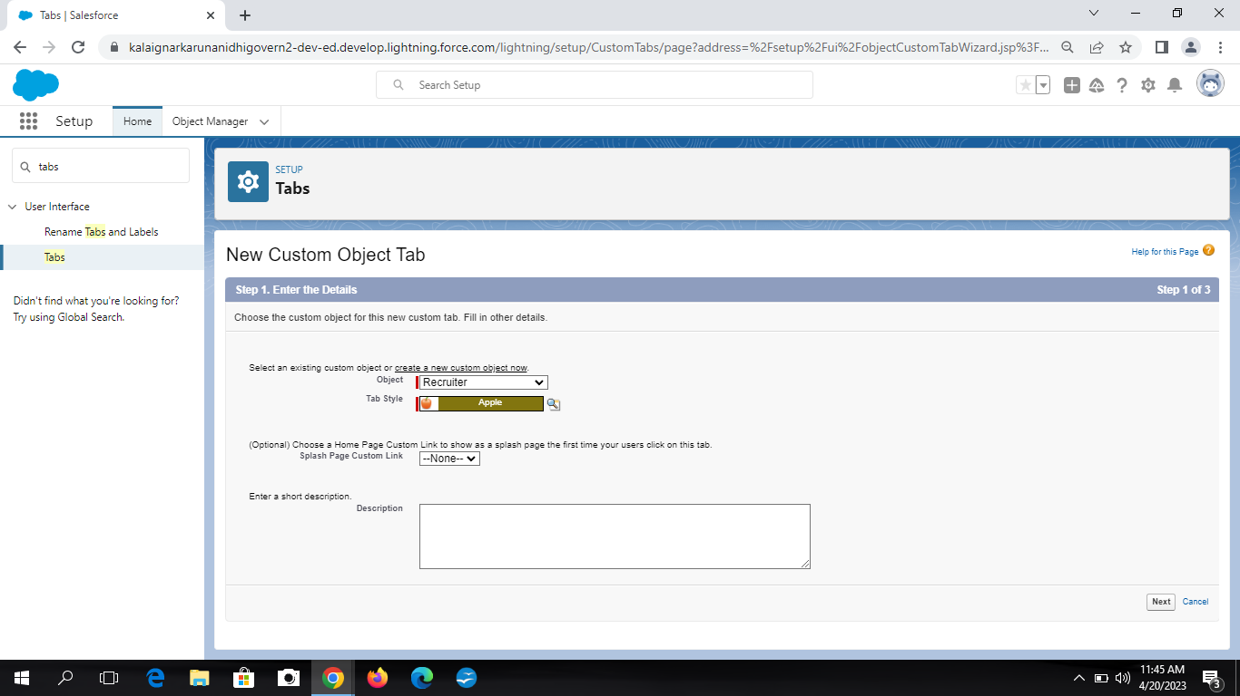

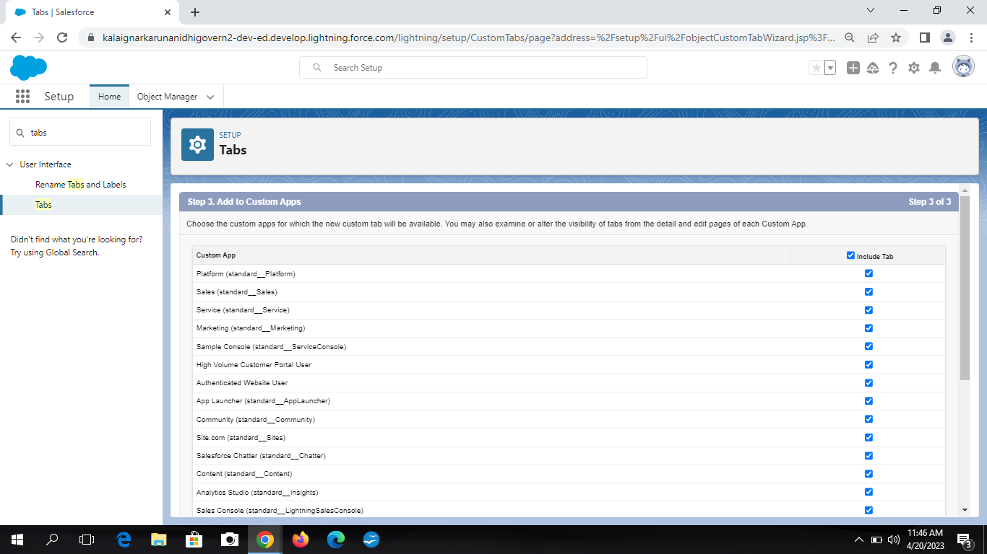Milestone: 5 Activities: 1

To create a custom profile from setup search profiles n find box and select profiles. Click clone then enter Recruiter and click save and create a new profile name as sales manager and save it.

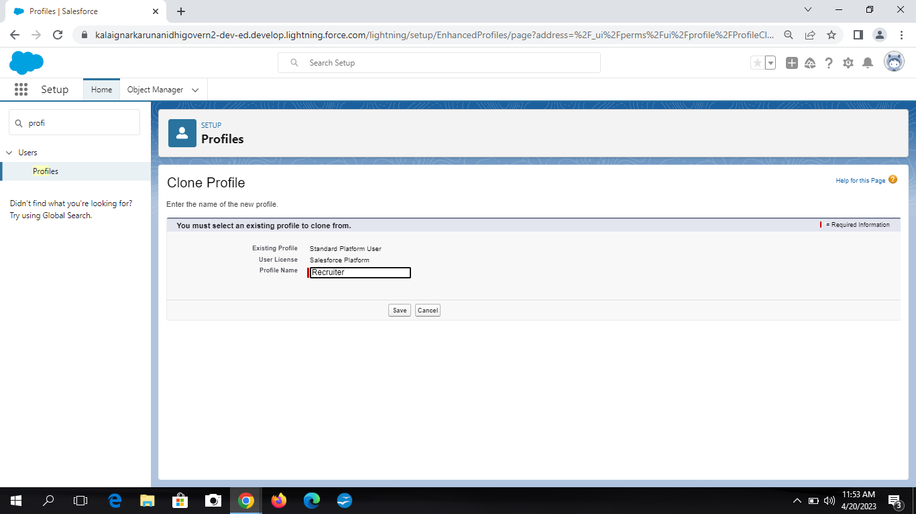

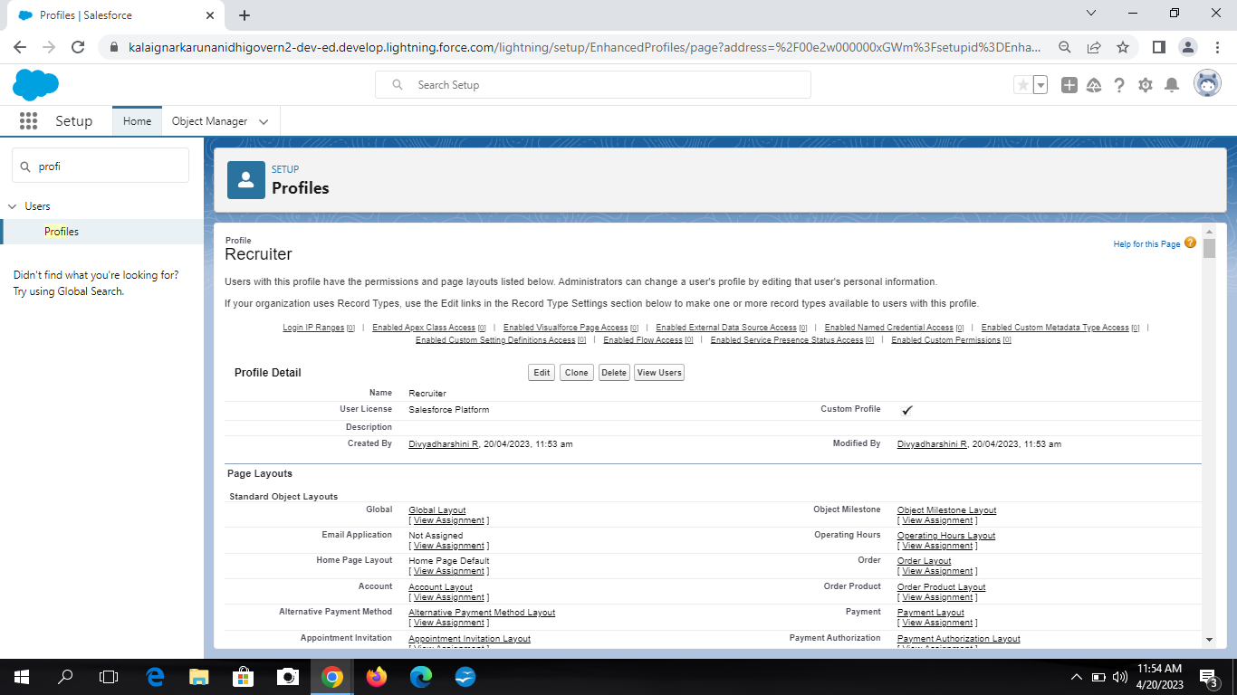

Activity: 2

Now by previous step create profile as sales manager.

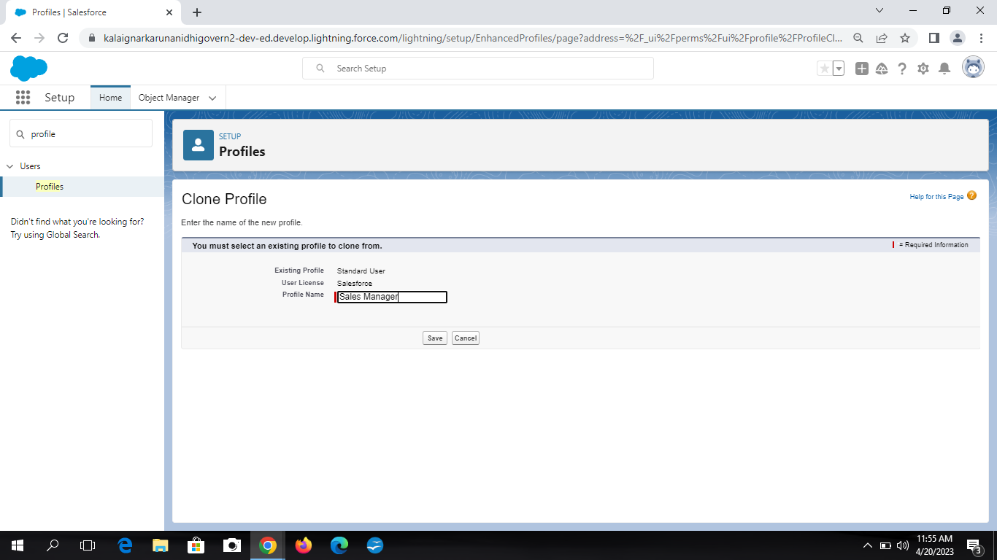

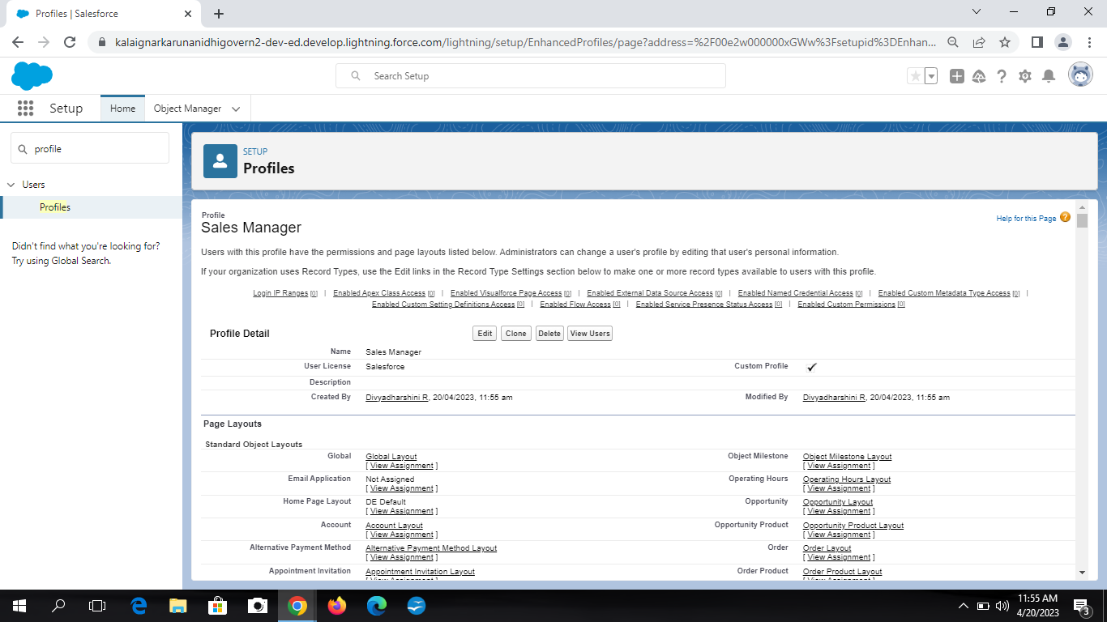Milestone: 6 Activities: 1

To create user from setup enter users in find box and select it. Now select new user and enter first name as Hr. and last name as Manager. Enter the user’s name and email address. Select profile and save it.

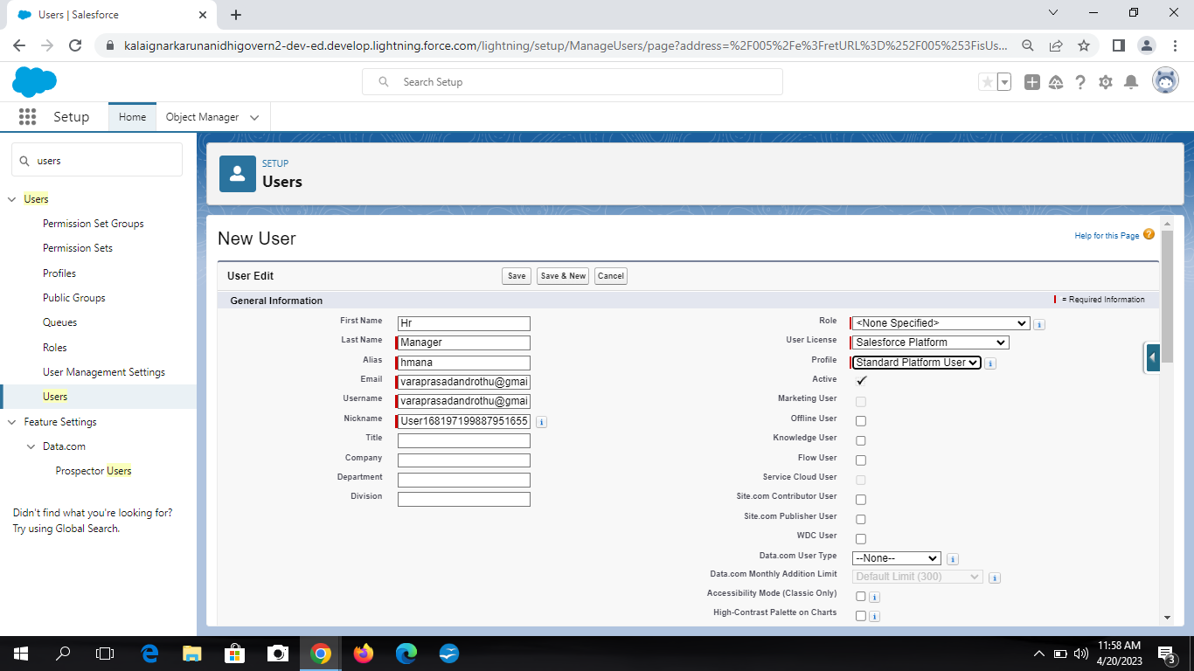

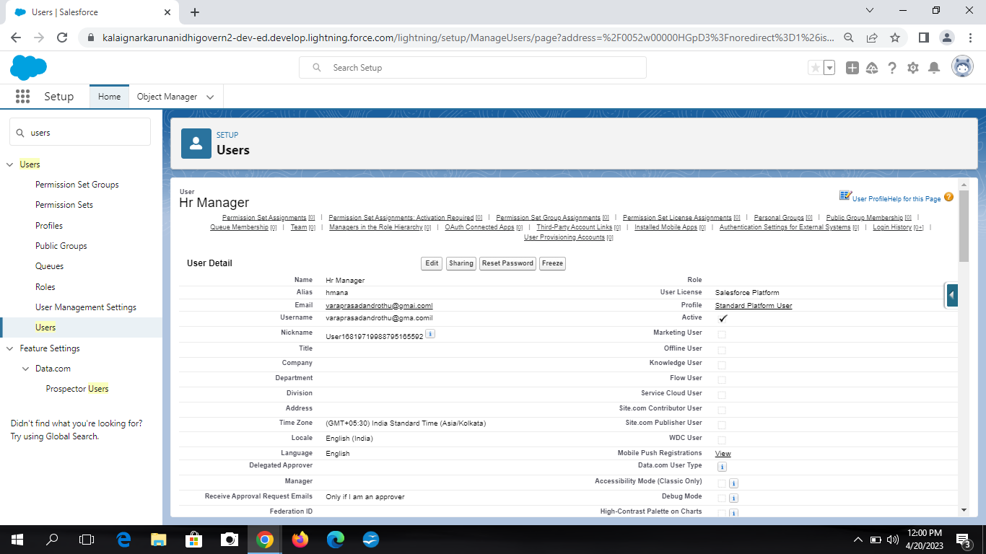

Acyivity:2

Repeat the above procedureand create user with name “Ganesh Gelli”.

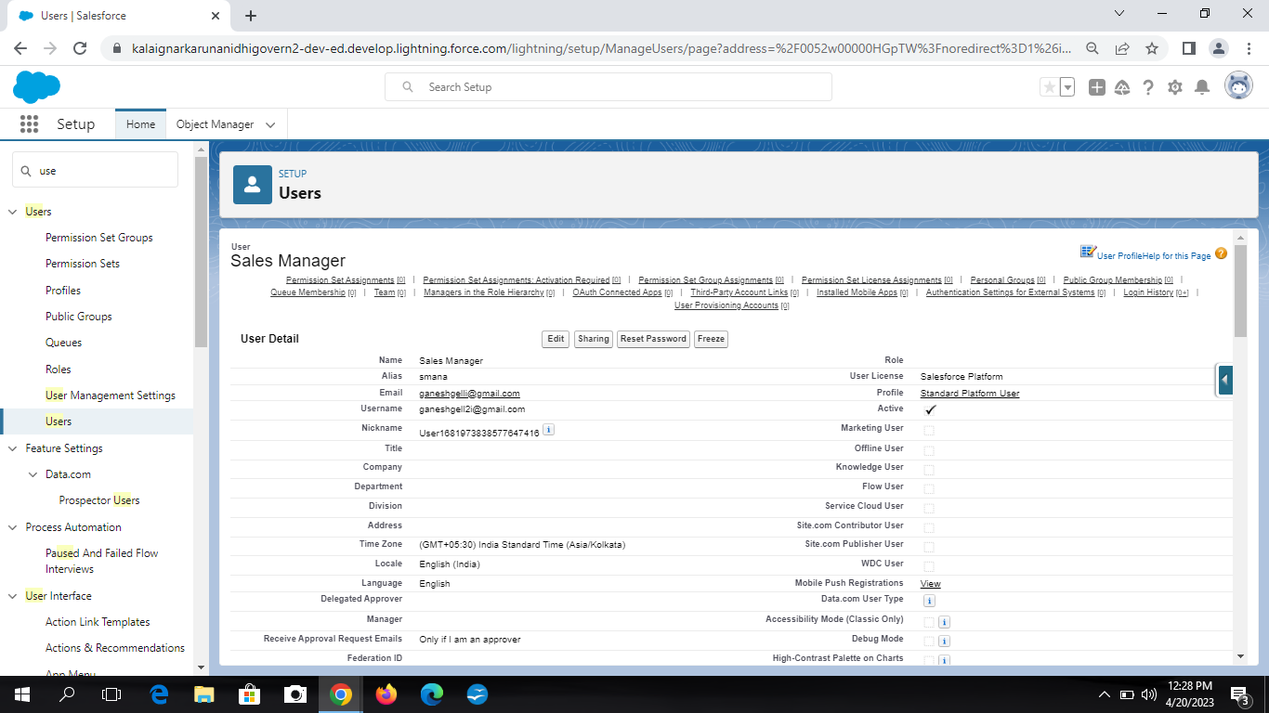

Milestone:7

Activity:1

To create a sharring rule, go to sharing settings. Select new to create new sharing rule. Type the name and role and select access as Read/Write and save the rule.

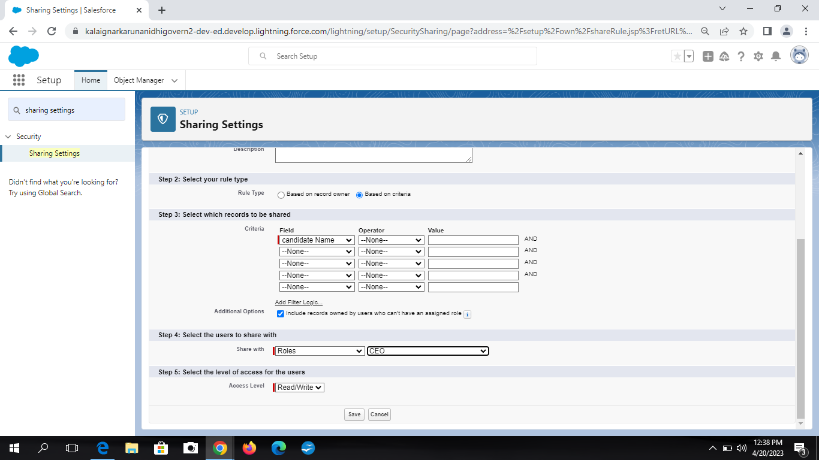

Activity:2

Again create a new sharig rule as Hr Manager.

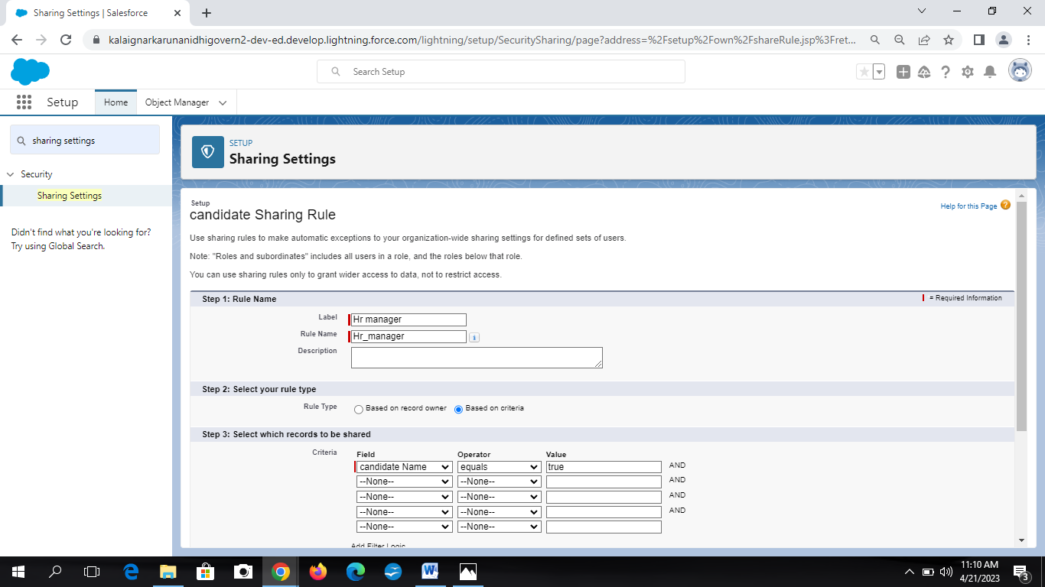

Milestone:8

Activity:1

To create Report click on app launcher and search for reports. Click new report and select category as accounts land contacts. Then select all accounts and all time. In outline pane, group row as rating and group column as account name. In column section add type and billing city. Save the report by given label name and save as public folder and save the report.

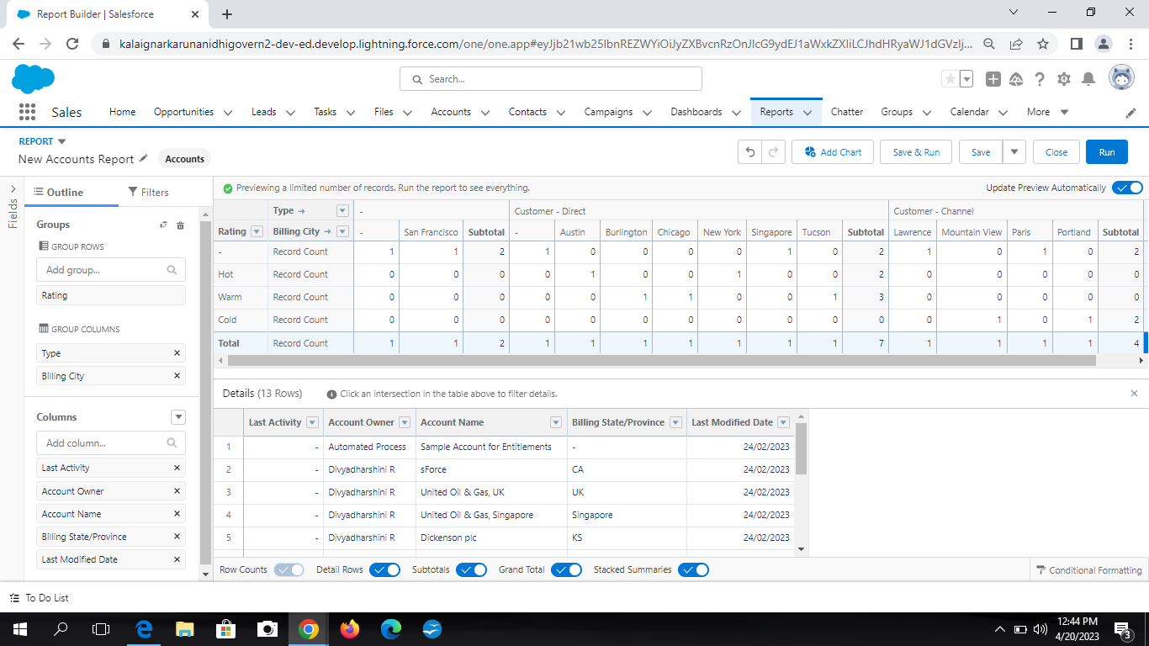

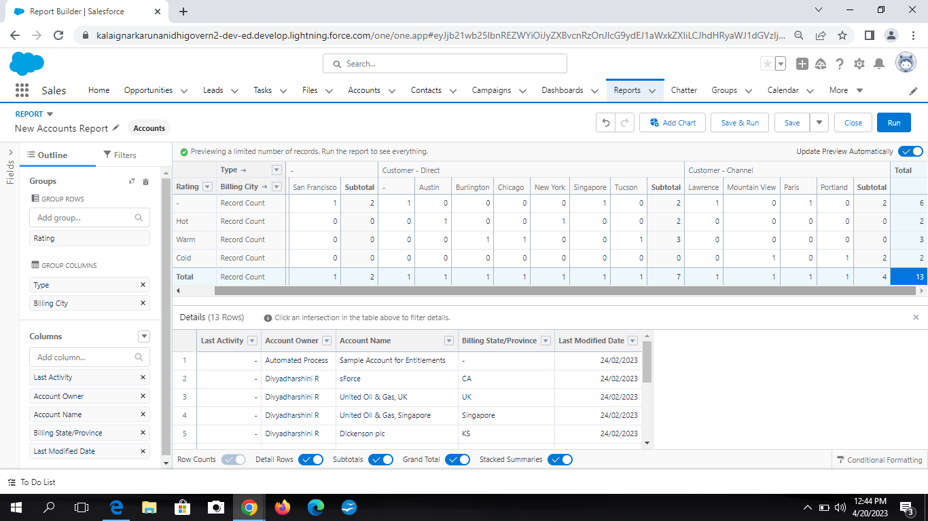

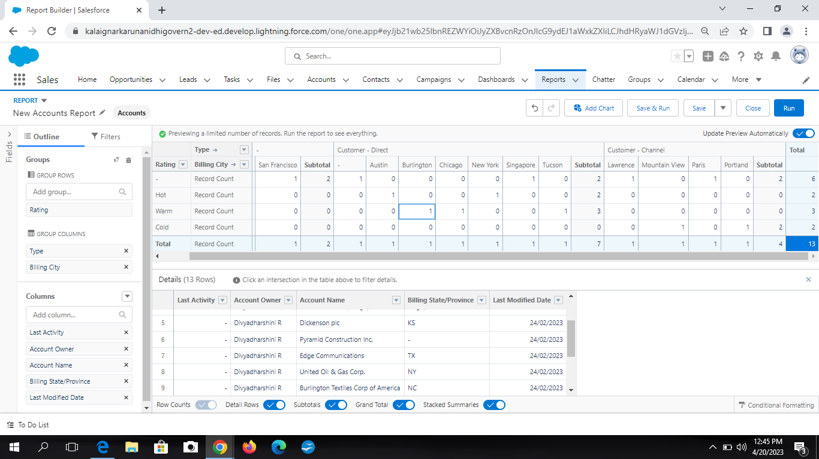

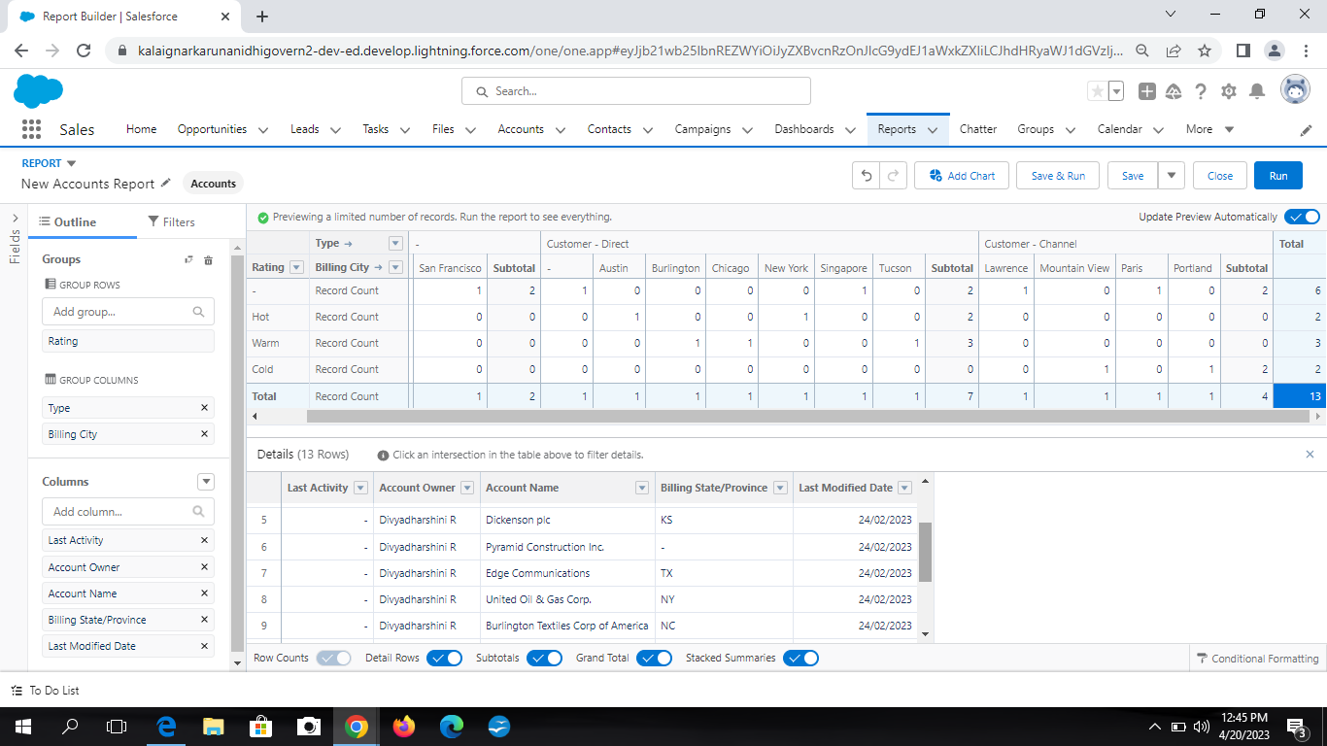

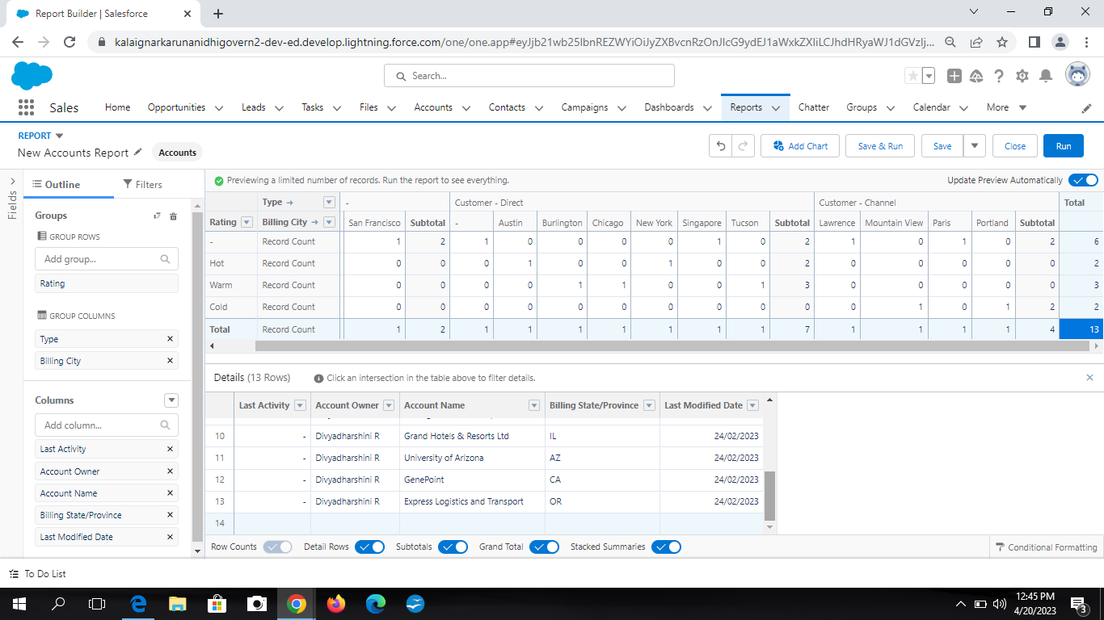

Activity:2

Again create a report using the object jobs. Candidate and Job application.

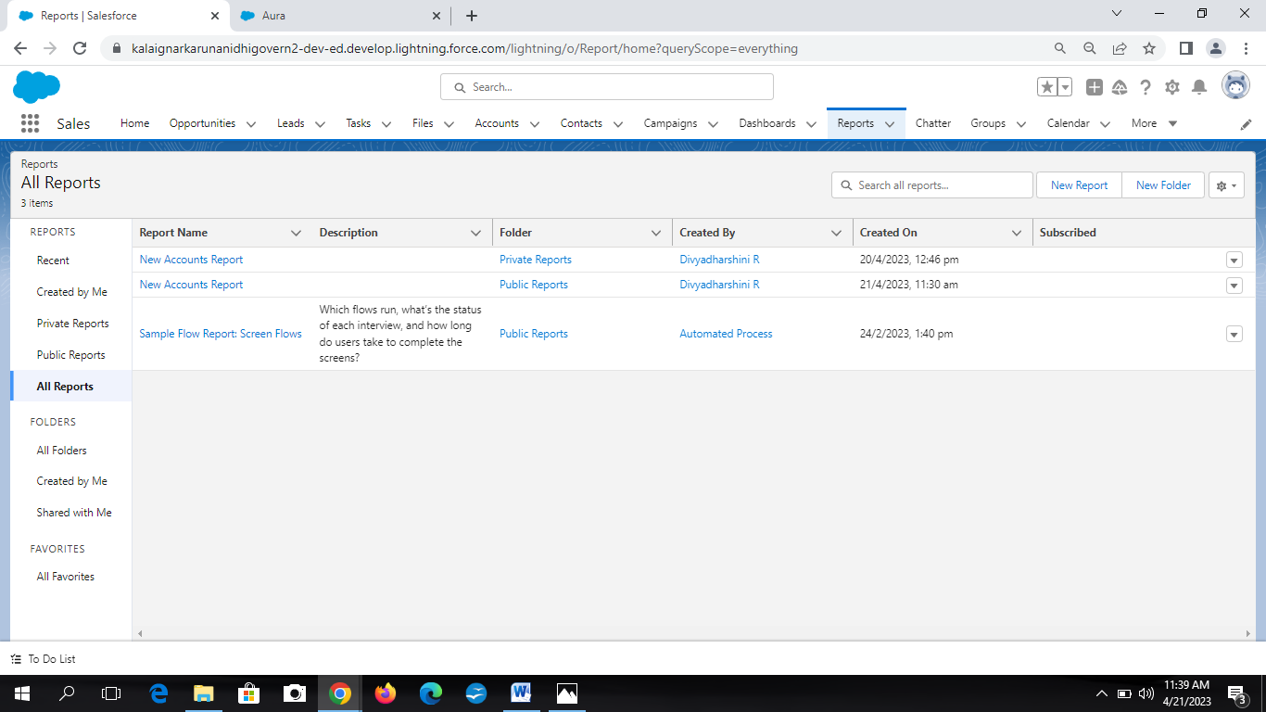

1. ***TRAILHEAD PROFILE PUBLIC URL***

Team Lead - https://trailblazer.me/id/divyr29

Team Member 1 - https://trailblazer.me/id/kpriya241

Team Member 2 - https://trailblazer.me/id/ggayathris1

Team Member 3 - https://trailblazer.me/id/hpriya1156

1. ***ADVANTAGES & DISADVANTAGES***

Advantages:

* + Flexible system both for the employer and the agency.
  + Easy job posting.
  + Faster and better decisions.
  + Improved inter-departmental communication.
  + Better overview of applications.
  + Easy to know the current status of job application.
  + Reduce time spend on admin tasks.

Disadvantages:

* + The disadvantage of JATS is missing qualified applicants due to wrong keyword selection.
  + Automatic elimination of resumes that software cannot recognize and interpret is another drawback.
  + It can open to manipulation.
  + Communication can be less personalized.

1. ***APPLICATIONS***
   * + It is used to filter the qualified resume in large commercial

Organizations.

* + - It is also applied to find the number of applications that has applied by the employers to the specific post.
    - It also helps the organization to reduce its time towards interview.
    - It also applied to hire qualified candidates.

1. ***CONCLUSION***

This requisition includes information about the position, such as the job title, desired skills, and required experience. The JATS then uses this information to create a profile for the ideal candidate. An applicant’s submit their resumes, the JATS parses, sorts, and ranks them based on how well they match the profile. Hiring managers then quickly identify the most qualified candidates and move them forward in the hiring process.

1. ***FUTURE SCOPE***

The world is moving into automation and AI, and leads way to the new age job applicant tracking system. Solutions were implemented only by few companies that could bear the heavy investment costs, now their use in the HR risen to the great extent. It will begin to like and act more like social network. There is a rise in AI based JATS. It has deep integration capabilities. There is a rise of cloud based JATS solutions. It will turn rejected talents into future hires analytics.